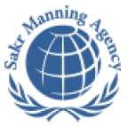 | SAKR MANNING AGENCY  FOR RECRUITING EGYPTIAN LABOR ABROAD | Issue Date | 15.05.2022
 | SAKR MANNING AGENCY  FOR RECRUITING EGYPTIAN LABOR ABROAD | Revision Date | 19.07.2022
 | Crewing Management Manual  Seafarer Employment Application | Revision | 1.1
 | Crewing Management Manual  Seafarer Employment Application | Page | 3

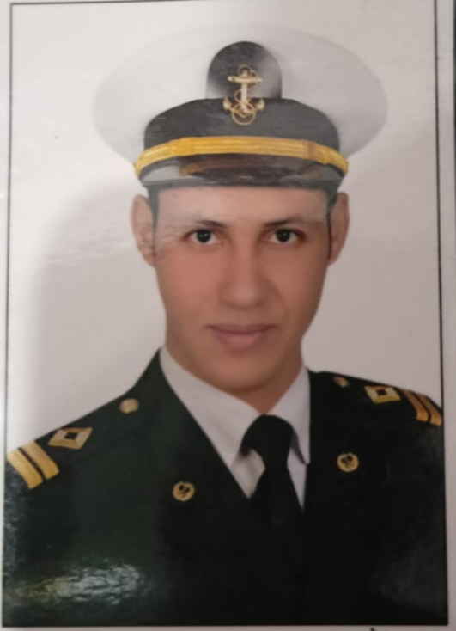
Application For Position as | 3rd engineer
Register Code. | EO-3.039
Other Position (If Any)
Register Date | 5/12/2022
Last up Date Data
Expected Salary

1. PERSONAL DETAILS
Full Name |  | Said Mohamed Mohamed Ghanem
Date Of Birth |  | 1/4/1992 |  |  |  |  |  |  | Place Of Birth |  |  |  |  |  |  |  | Kom hamada- beheira- Egypt
Nationality |  | Egyptian |  |  |  |  |  |  | Marital Status |  |  |  |  |  |  |  | Single |  |  |  |  |  |  |  | Married yes
Height (Cm) |  | 176 |  |  |  |  |  |  | Overall Size |  |  |  |  |  |  |  | Large |  |  |  |  | Shirt Size |  |  |  |  |  | Large
Weight (Kg) |  | 76 |  |  |  |  |  |  | Trouser Size |  |  |  |  |  |  |  | 36 |  |  |  |  | Shoes Size |  |  |  |  |  | 42
2. EDUCATION
College / School |  | The Arab Academy for science, Technology & Maritime transport
Marline Test |  | Issued Date |  |  |  |  | Result % |  |  |  | Issued By (Authority) |  |  |  |  |  |  |  |  |  | Issued At
English Language |  | Fluent |  |  |  |  |  | Good ✓ |  |  |  |  | Average |  |  |  |  |  |  |  | Poor
……… Language  ( ) |  | Fluent |  |  |  |  |  | Good |  |  |  |  | Average |  |  |  |  |  |  |  | Poor
3. CONTACT DETAILS
Home Address / City |  |  | Kom hamada/ beheira/ Egypt
E-Mail |  |  | sg6796947@gmail.com |  |  |  |  |  |  | Mobile / Tel |  |  |  |  |  | +201100085118

4. TRAVEL DOCUMENTS
Type |  | Document No. |  |  |  | ISS. Date |  |  | Exp. Date |  |  |  |  | ISS. By (Authority) |  |  |  |  |  |  |  |  |  | Place of Issue
Passport |  | A20782029 |  |  |  | 10/6/2017 |  |  | 9/6/2024 |  |  |  |  | Egyptian Authority |  |  |  |  |  |  |  |  |  | Egypt
Seaman Book |  | S00022958 |  |  |  | 31/5/2022 |  |  | 2/7/2025 |  |  |  |  | EAMS |  |  |  |  |  |  |  |  |  | Alex.
Other Seaman Book

5. PROFESSIONAL QUALIFICATION / CERTIFICATE OF COMPETENCY
Certificate Name |  |  |  |  | Number | Issue Date |  |  |  |  |  | Expiry Date |  |  |  |  |  | Issued By |  |  |  |  |  |  |  |  | Issued At
COC |  |  |  |  | 5508 | 31/5/2022 |  |  |  |  |  | 2/7/2025 |  |  |  |  |  | EAMS |  |  |  |  |  |  |  |  | Alex.
GOC |  |  |  |  |  |  |  |  |  |  |  |  |  |  |  |  |  | NTRA |  |  |  |  |  |  |  |  | Cairo
D.P. INDUCTION
D.P. ADVANCED
D.P. OPERATOR (UNLIMITED)
6. NEXT OF KIN
Full Name | NaglaaMosaad Mohamed El refaay |  |  |  |  |  |  |  |  |  |  |  |  |  | Relationship |  |  |  |  | Wife
Address | Kom hamada/ beheira/ Egypt
Tel. No. |  |  |  |  |  |  |  |  |  | Mobile |  |  | +201022517391
7. HEALTH CERTIFICATES & VACCINATIONS
Flag State |  |  |  | Number |  |  | Issue Date |  |  |  |  | Expiry Date |  |  |  |  |  |  | Issued By |  |  |  |  |  |  | Issued At
International Medical |  |  |  | 02995 |  |  | 12/6/2022 |  |  |  |  | 11/6/2024 |  |  |  |  |  |  | EAMS |  |  |  |  |  |  | Alex.
Yellow Fever |  |  |  | K5160/2 |  |  | 16/10/2014 |  |  |  |  | xxxxx |  |  |  |  |  |  | Ministry of Health |  |  |  |  |  |  | Alex.
Cholera |  |  |  |  |  |  |  |  |  |  |  |  |  |  |  |  |  |  | Ministry of Health
Covid-19 |  |  |  | Vaccination Name |  |  | First Dose |  |  |  |  | Second Dose |  |  |  |  |  |  | Third dose: 19/7/2022
 |  |  |  | Moderna |  |  | 26/12/2021 |  |  |  |  | 27/1/2022

8. MARINE COURSES
Course Name | Number | Issue Date | Expiry Date | Issued By / At
Personal Survival Techniques
Proficiency In Personal Survival Techniques | 14037/22/EG | 10/5/2022 | 9/5/2027 | The Arab Academy For Science, Technology& Maritime Transport
Fire Prevention and Fire Fighting
Advanced Fire Prevention and Fire Fighting | 14226/22/EG | 12/5/2022 | 11/5/2027 | The Arab Academy For Science, Technology& Maritime Transport
Elementary First Aid | 14265/22/EG | 12/5/2022 | 11/5/2027 | The Arab Academy For Science, Technology& Maritime Transport
Medical Care Studies
Personal Safety and Social Responsibilities | 14498/2/EG | 6/7/2020 | 1/7/2025 | The Arab Academy For Science, Technology& Maritime Transport
Proficiency Of Security Awareness Training Seafarers | 13950/20/EG | 29/6/2020 | 28/6/2025 | The Arab Academy For Science, Technology& Maritime Transport
Proficiency as a ship Security officer ( PSSO )
Proficiency In Survival Craft & Rescue Boats | 15160/20/EG | 13/7/2020 | 8/7/2025 | The Arab Academy For Science, Technology& Maritime Transport
G.M.D.S.S
Communications
Advanced Communications
ECDIS Advanced Simulator (Management Level)
ECDIS Simulator (Operation Level)
Prevention and Combating of Marine Pollution | 19690/17/EG | 24/7/2017 | xxxx | The Arab Academy For Science, Technology& Maritime Transport
Radar & ARPA Simulator and Search &rescue
ARPA Simulator and Search
Marine Radar and automatic Radar Plotting
Bridge resource Management (B.R.M)
Engine resource Management (E.R.M) | A20782029 | 7/11/2018 | 7/11/2023 | Piraeus- Greece
Navigational Watch keeping
Proficiency for Rating forming part of Navigational watch (II/4) |  |  |  | EAMS / Alex.
High voltage training – operation of ship (1000 Volt and More)
Passenger Safety Cargo Safety and Hull integrity
Crowd Management Training
Crisis Management and Human Behavior Training
Safety training for Personal Prov. Direct Passengers
Practical Ability to Prepare Meals and (MLC 2006)
Personal Hygiene and Envir. Protection (MLC 2006)
Safety and Health in the Provision Meals (MLC 2006)
Food Storage and inventory Control (MLC 2006)
Ships Cook Certificate (MLC 2006) |  |  |  | EAMS / Alex.
Abel Seafarer Deck
Proficiency for Abel Seafarer Deck ( II/5 ) |  |  |  | EAMS / Alex.
Engineering Watch keeping |  |  |  | EAMS / Alex.
Proficiency for Rating forming part of a watch in engine room
Abel Seafarer Engine
Proficiency for Abel Seafarer Engine ( III/5 ) |  |  |  | EAMS / Alex.
Electro Technical Rating
Proficiency for Electro Technical rating ( III/7 ) |  |  |  | EAMS / Alex.
Operational level course engineering department | 14417/22/EG | 15/5/2022 | 11/5/2027 | The Arab Academy For Science, Technology& Maritime Transport

COMPLETE SEA – SERVICE DETAILS

Name: |  |  |  |  |  |  |  | Rank: |  |  |  |  |  |  |  | Register Code:
Company Name |  |  | Rank |  | Vessel Name |  |  |  | Signed On |  |  | Signed Off |  |  |  | Period |  |  | Vessel Type |  | D.W.T. |  |  |  |  | Engine Type |  |  | BH | KW
Rek nav |  |  | 3rd Eng |  | rek noble |  |  |  | 02/09/2021 |  |  | 29/03/2022 |  |  |  | 7 months |  |  | Bulk carrier |  | 20001 M.T |  |  |  |  | MAN&B&W 8S35MC- MK7 |  |  |  | 5920
Rek Nav |  |  | 3rd Eng |  | rek noble |  |  |  | 12/08/2020 |  |  | 13/02/2021 |  |  |  | 7 months |  |  | Bulk carrier |  | 20001 M.T |  |  |  |  | MAN&B&W 8S35MC- MK7 |  |  |  | 5920
Merp shipping |  |  | 3rd Eng |  | Milano.1 |  |  |  | 29/07/2017 |  |  | 08/07/2019 |  |  |  | 2 years |  |  | General cargo |  | 6540 M.T |  |  |  |  |  |  |  | 4000 | 3000
Gahani |  |  | AsstEng |  | DODO |  |  |  | 30/10/2014 |  |  | 26/08/2015 |  |  |  | 10 months |  |  | RORO |  | 8292 M.T |  |  |  |  | 2X NORMO BERGEN KVM12 |  |  | 4000 | 3000
Gahani |  |  | AsstEng |  | DODO |  |  |  | 03/10/2015 |  |  | 27/06/2016 |  |  |  | 9 months |  |  | Roro |  | 8292 M.T |  |  |  |  | 2X NORMO BERGEN KVM12 |  |  | 4000 | 3000
Sun shine shipping |  |  | Asst Eng |  | Dahra |  |  |  | 28/07/2011 |  |  | 29/08/2014 |  |  |  | 3 years |  |  | Tanker |  | 3600 T |  |  |  |  | 1MAK 8m 453ak |  |  | 4000 | 3000
SPECIALISED EXPERIENCE
Name |  |  |  |  |  |  |  |  |  | Type |  |  |  | From |  |  | To |  |  |  |  | Comments
I declare that the information I have given is, to the best of my knowledge, true and complete. I also declare that the documents submitted are genuine, given and sign by persons whose names appear on them.
 |  |  |  |  |  |  |  |  |  |  |  |  |  |  | DATE |  |  |  |  |  |  |  |  |  | SIGNATURE

